SIMATS ENGINEERING (SAVEETHA SCHOOL OF ENGINEERING)
Department of Computer Science and Engineering
ASSESSMENT TOOL 3 – FUNCTION CALLING & STRUCTURED OUTPUT TASK

Course Code: | CSA6502 | Course Title: | Generative AI and Large Scale  Models
CO Assessed: | CO2 – Precision (BL2, BL3) | Assessment: | Assessment Tool 3 – Function  Calling & Structured Output Task
Weightage: | 40% of CIA | Total Marks: | 1 * 100 = 100 (1 Question1)
CO2 Statement: | Apply prompt engineering techniques and utilize pre-trained Large Language Models through modern AI frameworks and APIs to solve real-world problems (BL2, BL3)
Student Name: | C. Anu Keerthana | Reg. No.: | 192472057
Section / Batch: |  | Date:

Instructions to Students
· Answer 1 question. Total: 100 Marks.
· Analyze the given scenario and identify the appropriate function(s), tool(s), parameters, and structured output required to solve the task.
· Design a valid function-calling schema with appropriate function names, parameters, data types, required fields, and descriptions based on the given requirements.
· Implement the function-calling workflow demonstrating the complete process: User Query → LLM → Function/Tool Call → Function Execution → Structured Response.
· Ensure that the generated output strictly follows the defined structured format or JSON schema and contains valid, relevant, and consistent information.
· Handle appropriate edge cases such as missing parameters, invalid inputs, ambiguous requests, incorrect data types, or unavailable information, and provide suitable responses without producing invalid function calls.
· Demonstrate the working implementation using suitable test cases, including normal inputs and at least one edge-case scenario.
· Clearly document the designed schema by explaining the purpose of each function, its parameters, data types, required fields, expected input, and expected output.
· Briefly justify the design decisions and explain how function calling and structured output improve the reliability, consistency, and usability of the LLM-based application. Submission Requirements Students should submit:
- Source code / Jupyter Notebook
- Function-calling schema
- Structured output/JSON schema
- Execution screenshots
- Test cases and results
- Brief documentation explaining the schema and function-calling workflow

Code of Conduct
I _________C. Anu Keerthana(192472057)_________________ (Name / Reg No) certify that this submission is my original work and that I have adhered to the guidelines specified for this assessment. I understand that any violation of academic integrity rules will result in disciplinary action.
Signature of the Student: ________C. Anu Keerthana_________________

SECTION A –– FUNCTION CALLING & STRUCTURED OUTPUT TASK

13. Invoice Information Extractor
A company wants to automatically extract information from invoices.
Task: Design a structured output schema containing invoice number, date, vendor, total amount, tax, and payment status. Demonstrate how the LLM should respond when a field is missing.

1. Problem Statement
A company receives invoices from multiple vendors in different formats. Manually extracting invoice details is time-consuming and prone to errors.
The goal is to use an LLM with function calling to automatically extract invoice information into a structured JSON format.

2. User Query

Extract invoice information from the following invoice.
Invoice:
ABC Technologies Pvt Ltd
Invoice No: INV-2026-101
Date: 15-07-2026
GST: ₹810
Total Amount: ₹5310
Payment Status: Paid

3. Function Calling Schema

Function Name
extract_invoice_details
Description
Extracts important invoice information from invoice text.

Parameters
Parameter | Type | Required | Description
invoice_text | string | Yes | Complete invoice text

Function Schema (JSON)
{
"name": "extract_invoice_details",
"description": "Extract invoice details from invoice text.",
"parameters": {
"type": "object",
"properties": {
"invoice_text": {
"type": "string",
"description": "Complete invoice text"
}
},
"required": [
"invoice_text"
]
}
}

4. Structured Output Schema
{
"invoice_number": "string",
"invoice_date": "string",
"vendor": "string",
"total_amount": "number",
"tax": "number",
"payment_status": "Paid | Pending | Overdue | Unknown"
}

5. Function Calling Workflow
User Query
│
▼
Large Language Model
│
▼
Calls Function
extract_invoice_details()
│
▼
Function Executes
│
▼
Returns JSON Output

6. Python Implementation
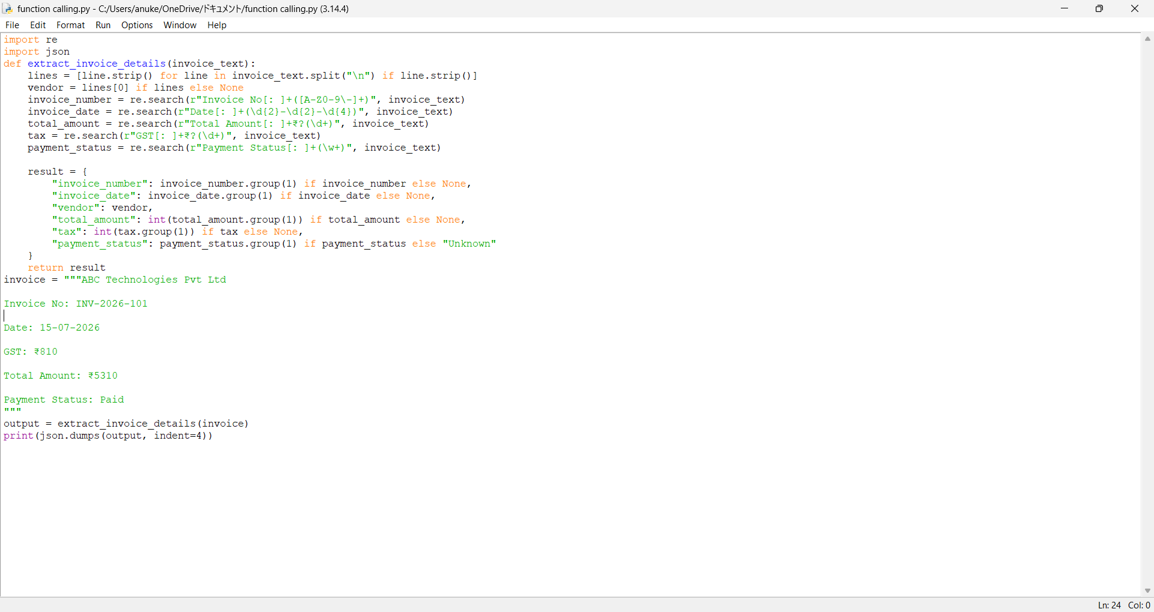

7. Execution Screenshot
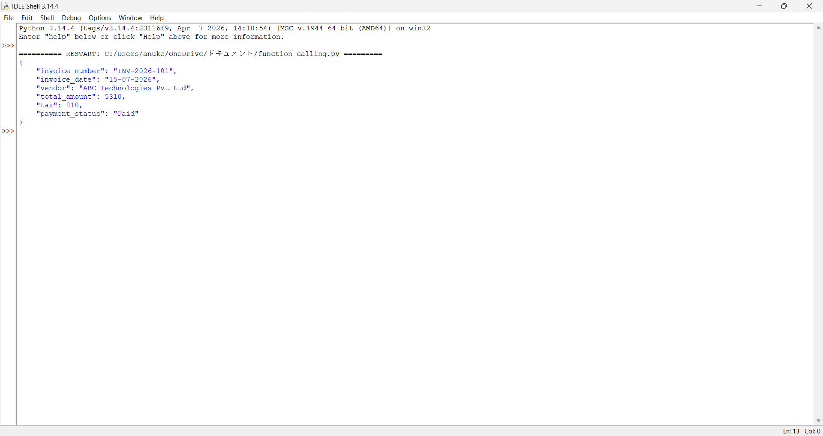
8. Test Case 1 (Normal Input)
Input
ABC Technologies Pvt Ltd

Invoice No: INV-2026-101

Date: 15-07-2026

GST: ₹810

Total Amount: ₹5310

Payment Status: Paid
Output
{
"invoice_number": "INV-2026-101",
"invoice_date": "15-07-2026",
"vendor": "ABC Technologies Pvt Ltd",
"total_amount": 5310,
"tax": 810,
"payment_status": "Paid"
}
9. Test Case 2 (Missing Tax)
Input
XYZ Electronics

Invoice No: INV-300

Date: 01-08-2026

Total Amount: ₹8200

Payment Status: Pending
Output
{
"invoice_number":"INV-300",
"invoice_date":"01-08-2026",
"vendor":"XYZ Electronics",
"total_amount":8200,
"tax":null,
"payment_status":"Pending"
}
This satisfies the instruction to handle missing parameters by returning null instead of inventing a value.

10. Edge Case
Input
XYZ Traders

Invoice No: INV-500
Output
{
"invoice_number":"INV-500",
"invoice_date":null,
"vendor":"XYZ Traders",
"total_amount":null,
"tax":null,
"payment_status":"Unknown"
}
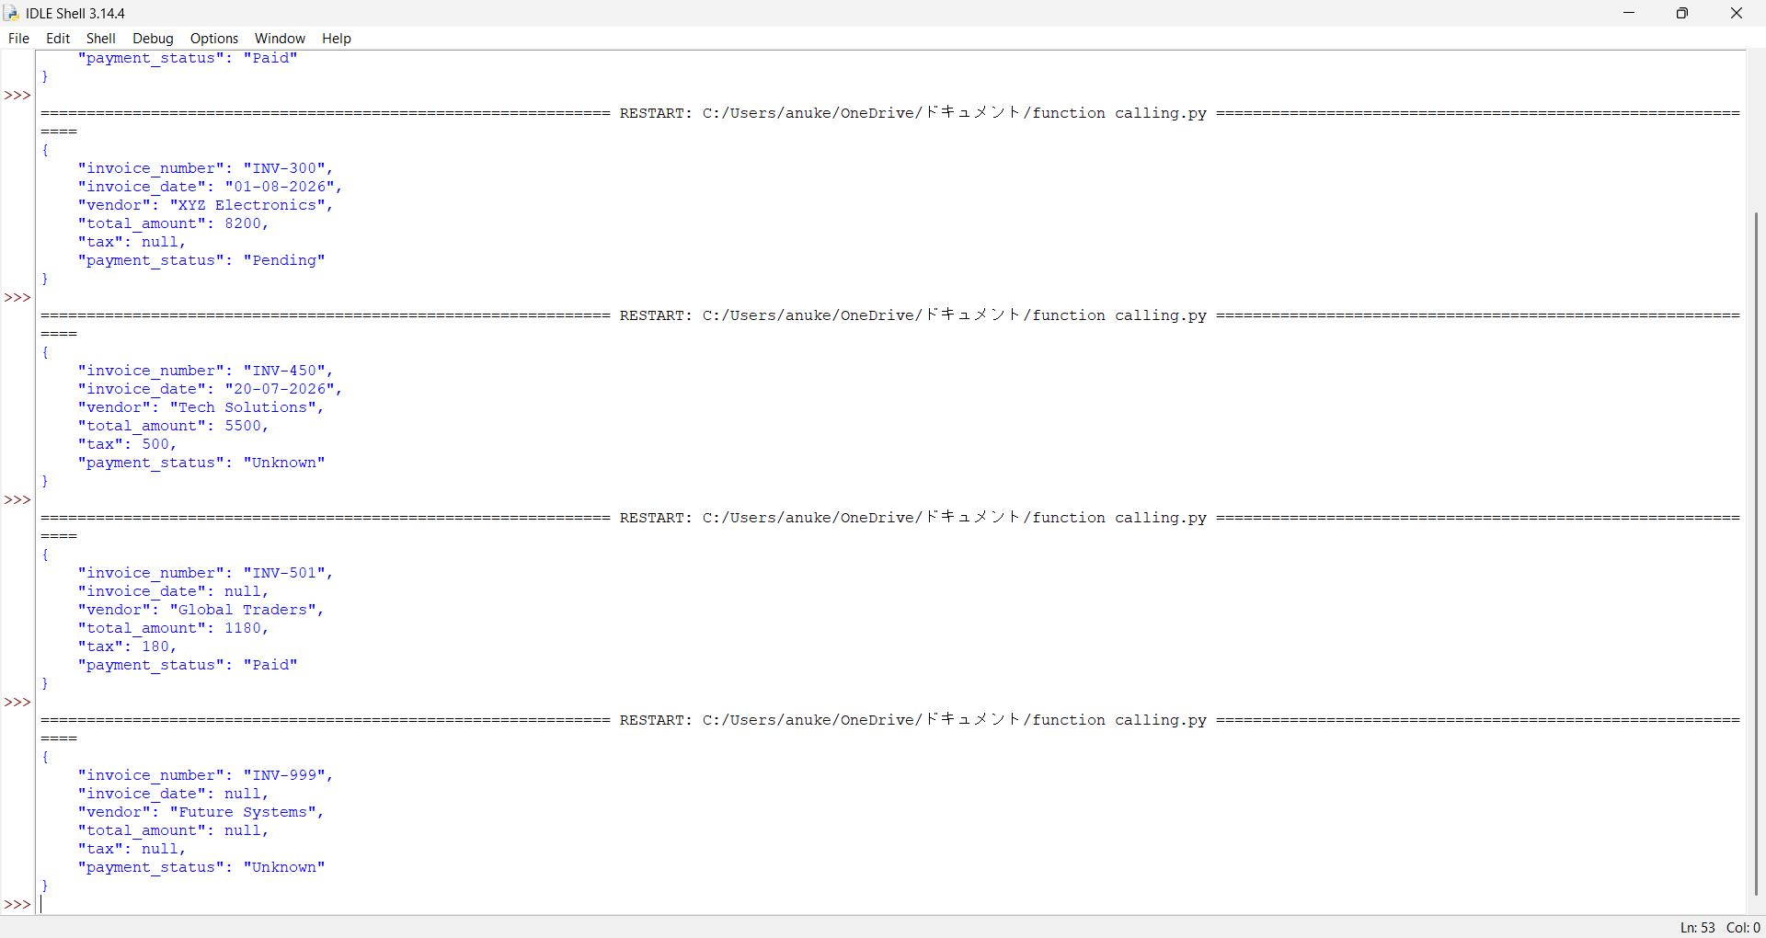

11. Explanation of the Schema
The function extract_invoice_details receives the invoice text as input and extracts the required fields. The output is returned as structured JSON with consistent keys. If any information is missing, the function returns null (or "Unknown" for the payment status), ensuring reliable and predictable results.

12. Advantages
- Reduces manual data entry.
- Ensures consistent JSON output.
- Handles missing information safely.
- Easy to integrate with ERP and accounting systems.
- Improves accuracy and automation.

Justification of the Problem Statement
Businesses receive invoices from multiple vendors in different formats, such as PDFs, scanned documents, and emails. Manually extracting key details like invoice number, date, vendor name, total amount, tax, and payment status is time-consuming, repetitive, and prone to human error. As the number of invoices increases, manual processing becomes inefficient and delays financial operations.
Using a Large Language Model (LLM) with function calling provides an automated and reliable solution. The LLM understands the invoice content and invokes a predefined function to extract only the required information. The extracted data is then returned in a structured JSON format, making it easy to store in databases, integrate with ERP or accounting systems, and use for further processing.
This approach offers several advantages:
- Accuracy: Reduces errors caused by manual data entry.
- Consistency: Every invoice is converted into the same structured format.
- Efficiency: Processes invoices much faster than manual methods.
- Scalability: Can handle thousands of invoices from different vendors.
- Reliability: Missing fields are returned as null or "Unknown" instead of generating incorrect information.
Therefore, implementing an Invoice Information Extractor using LLM function calling and structured output is an effective solution for automating invoice processing, improving productivity, and ensuring consistent and reliable data extraction.

RUBRICS FOR CALCULATION

Criteria | Weightage | Level 4 – Exemplary | Level 3 – Proficient | Level 2 –  Developing | Level 1 –  Beginning
Schema Design | 30% | Correctly designs a function-calling schema and structured (JSON) output format | Mostly correct schema with minor issues | Schema has  significant errors | Schema is fundamentally incorrect or missing
Output Validity | 25% | LLM reliably produces valid structured output matching the schema | Mostly valid output with occasional errors | Output is frequently invalid or inconsistent | Output rarely or never matches the schema
Edge-Case Handling | 20% | Handles edge cases  (missing fields, ambiguous input) gracefully | Handles common cases well | Handles only the simplest cases | Fails on basic cases
Function-Call Flow Demo | 15% | Clear demo of the function-call to structured-response flow | Demo covers the main flow | Demo is incomplete | No functional demo presented
Schema Documentati on | 10% | Well-documented  schema design rationale | Adequate documentation | Minimal documentation | No documentation provided

Marks Evaluation:
Question No. | Schema Design(30%) | Output Validity (25%) | Edge-Case  Handling  (20%) | Function-Ca ll Flow  Demo(15%) | Schema  Documentation (10%) | Total Marks (100)
Q1
 |  |  |  | Overall Total (100)

Faculty In-charge | Course Coordinator | Head of Department
Signature: _______________ | Signature: _______________ | Signature: _______________
Date: ___________________ | Date: ___________________ | Date: ___________________

